Treasury Wire Payment

**Treasury Wire Setup**

1. Go to Treasury Wire Setup

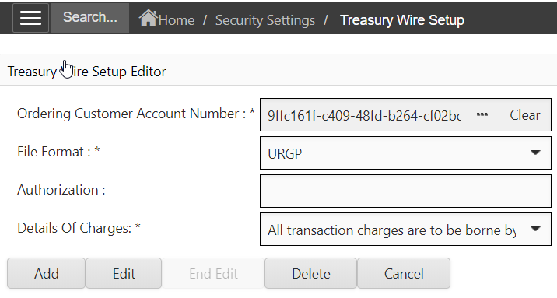

1. Specify the ordering customer beneficiary account number
2. Specify the File Format (URGP, NURG, SEPA, etc…)
3. Specify charge details and click add

**Add Treasury Wire Payment**

1. Go to Treasury Wire page

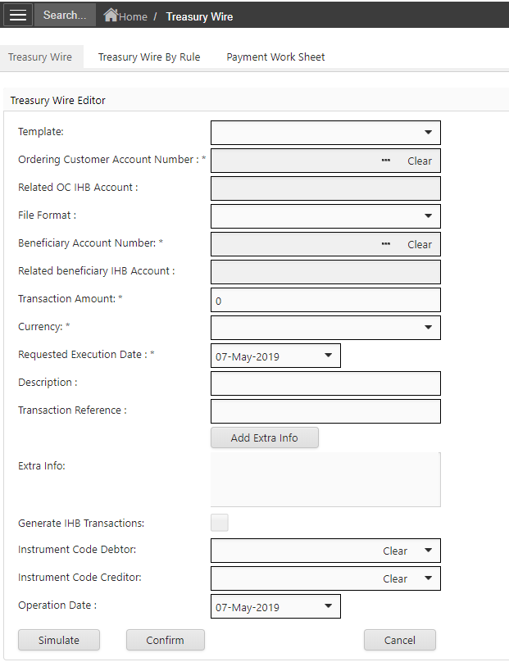

1. Select the Ordering Customer Account Number (which the Setup Rule was created)
2. Select File format (Format specified in the setup rule will be displayed)
3. Select Beneficiary account number
4. Specify the amount, current and date
5. Click Simulate to view how the Ordering Customer and Beneficiary Account will be Debited and Credited with this Treasury Wire payment
6. Click Confirm to save the payment (confirm posting the payment)

